**SYSTEM DESIGN**

**Data Flow Diagram / Use Case Diagram / Flow Diagram**

The DFD is also called as bubble chart. It is a simple graphical formalism that can be used to represent a system in terms of the input data to the system, various processing carried out on these data, and the output data is generated by the system.

**ARCHITECTURE DIAGRAM:**

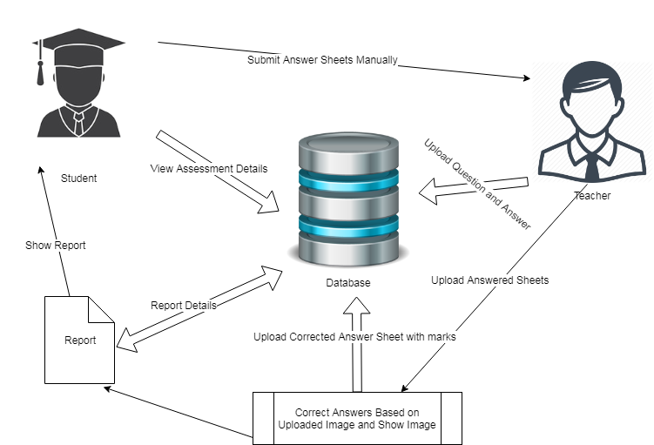

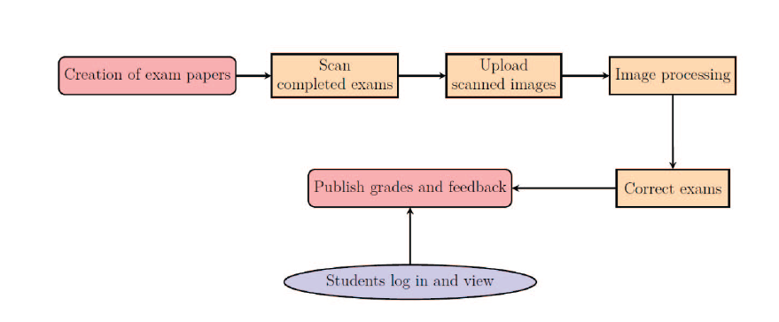

**SEQUENCE DIAGRAM:**

FACULTY

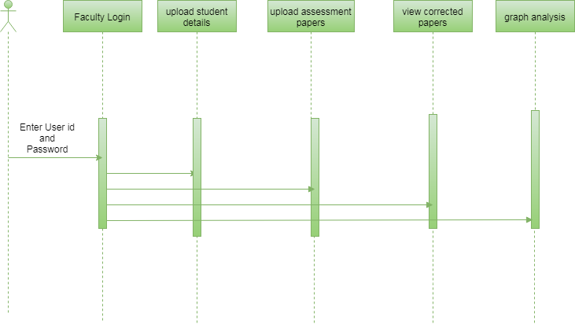

STUDENT

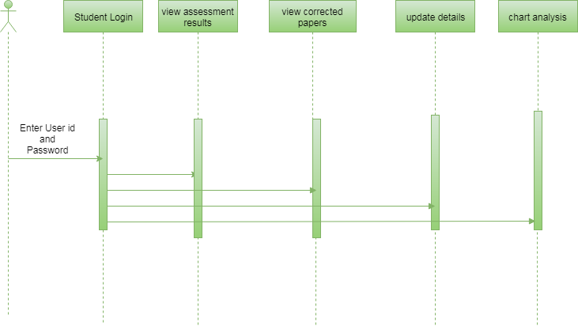

**ACTIVITY DIAGRAM:**

FACULTY

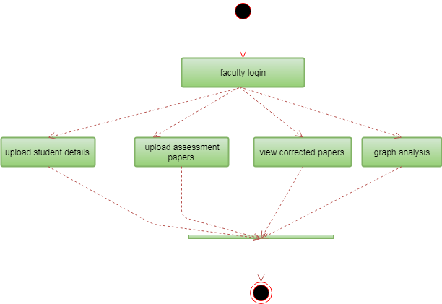

STUDENT

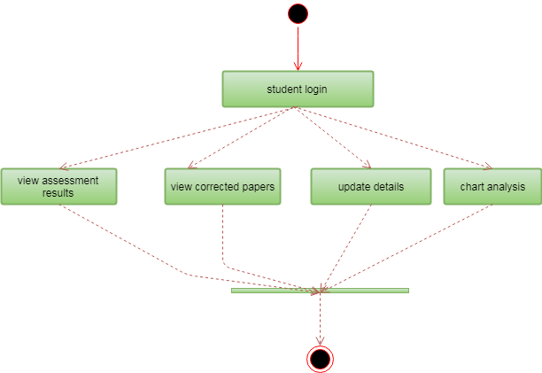

**USECASE DIAGRAM:**

FACULTY

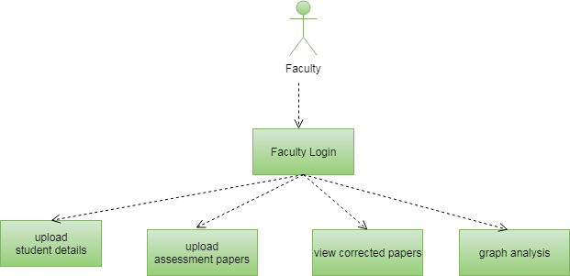

STUDENT

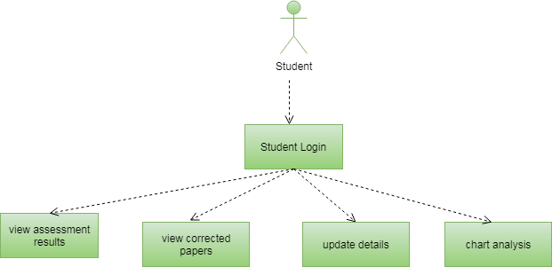

**COMPONENT DIAGRAM:**

FACULTY

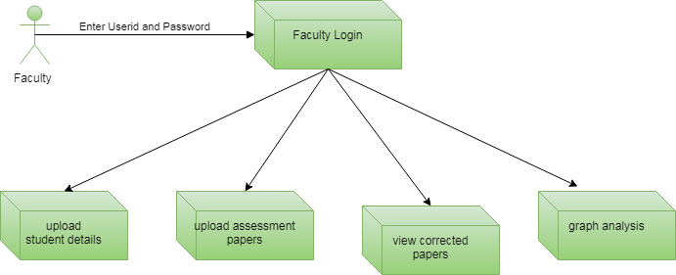

STUDENT

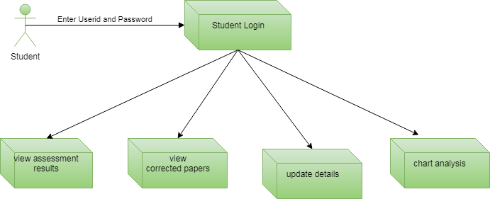

**CLASS DIAGRAM:**

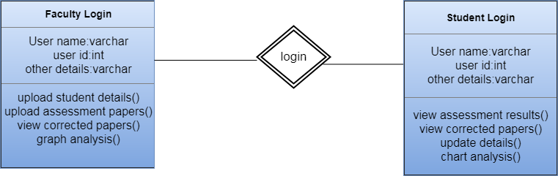

**ER DIGRAM:**

FACULTY

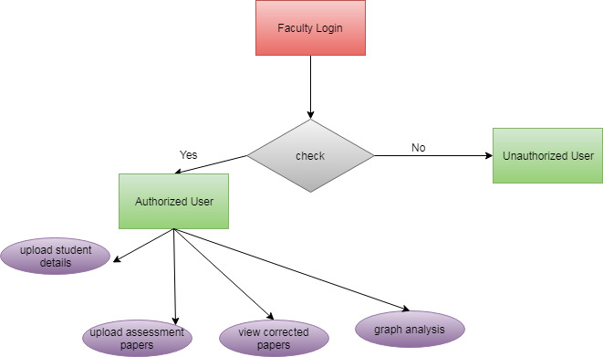

STUDENT

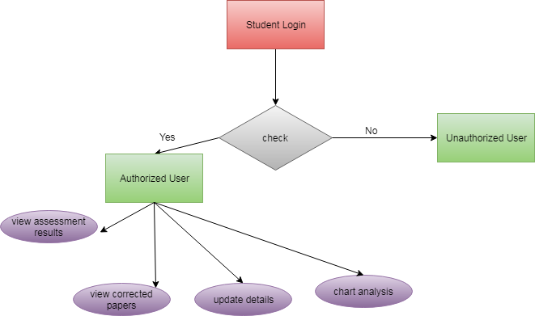

**DATA FLOW DIAGRAM:**

FACULTY

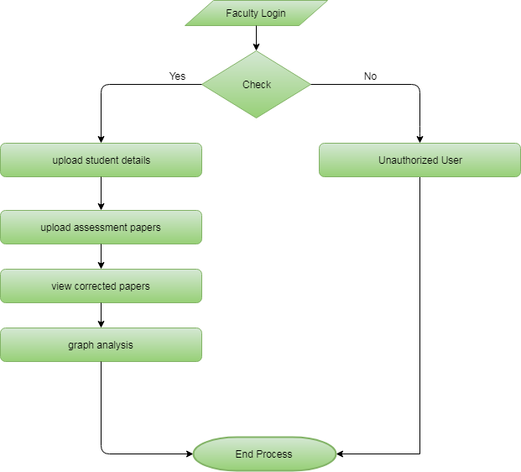

STUDENT

